**Section 6: Titles and Epithets for the Buddha**

This section we will focus on how the Buddha was titled—the many epithets for the Buddha. In the scriptures we can find many titles bestowed upon the Blessed One, a few selected ones are discussed here.

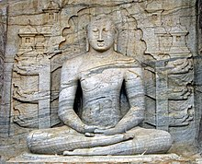

**Sitting Buddha, Gal Vihara, Sri Lanka**: Picture courtesy: Wikipedia

https://en.wikipedia.org/wiki/Gal_Vihara

**The Buddha is a Sublime Gem**

“There’s no wealth here or beyond,

no sublime gem in the heavens,

that equals the Realized One.

This sublime gem is in the Buddha:

by this truth, may you be well!” [1]

**The Buddha is the Foremost in the World**

“In this world together with its devas

above, across, and below,

as far as the world extends,

the Buddha is declared foremost” [2]

**The Nature of the Buddha**

“The perfect Buddhas of the past,

the Buddhas of the future,

and the present Buddha

who removes the sorrow of many:

all those dwelled, now dwell,

and in the future will dwell

revering the good Dhamma.

This is the nature of the Buddhas”[3]

**Buddha is peerless**

“When, through direct knowledge,

the Buddha, the teacher, the peerless person

in this world with its devas,

sets in motion the wheel of Dhamma,

he teaches personal existence, its cessation,

the origin of personal existence,

and the noble eightfold path

that leads to the calming down of suffering” [4]

**▲ Buddha**

The Pali term “Buddha” translates to “the awakened one” or “enlightened one,” expressing a buddha’s profound understanding of the true nature of reality. He was referred as the Buddha by his followers. Often in the scriptures we can see that the Blessed One also addressed himself as the Buddha.

♦ **Buddha who Understood the Liberation and Taught it to Others**

According to the following sutta, it is clear that the Blessed One is called 'Buddha' because he realized four things and he directed his followers towards liberation.

*“It is, bhikkhus, because of not understanding and penetrating noble virtuous behaviour, noble samadhi, noble wisdom, and noble liberation that you and I have roamed and wandered for such a long stretch of time…noble virtuous behaviour… samadhi …wisdom… noble liberation understood and penetrated…”*

Then the Blessed One said:

*“Virtuous behaviour, samadhi, wisdom,*

*and unsurpassed liberation:*

*these things the illustrious Gotama*

*understood by himself.*

*Having directly known these things,*

*The Buddha taught the Dhamma to the bhikkhus.*

*The Teacher, the end-maker of suffering,*

*the One with Vision, has attained nibbana”[5]*

♦ **The Buddha is a Noble One who Knows All**

The following verses illuminate the meaning of the term ‘Buddha’.

When, Brahmin Sela inquired about the enlightenment, the Buddha says thus:

*“What must be known is directly known,*

*What must be developed has been developed,*

*What must be abandoned has been abandoned,*

*Therefore, brahmin, I am a Buddha”*

After listening to the teaching of the Blessed One, brahmin Sela having established confidence, said:

*“You are the Buddha, you are the Teacher,*

*You are the Sage, the conqueror of Māra.*

*Having cut off all evil tendencies,*

*You have crossed and guide humanity across [6].*

♦ **The Arising of a Buddha is Rare**

*“It’s hard to gain a human birth;*

*the life of mortals is hard;*

*it’s hard to hear the true teaching;*

*the arising of Buddhas is hard”*  [7]

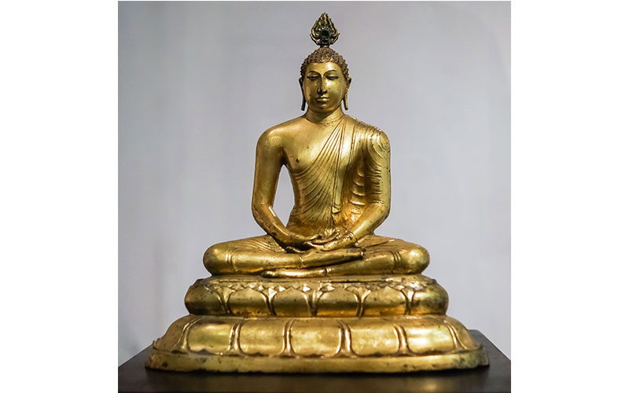

**The Buddha sitting on a lotus:** Veheragala Buddha statue, Sri Lanka Picture courtesy: https://www.lifie.lk/

♦ **Buddha is a Noble One who is not Fouled by the Word**

According to scriptures, when Brahmin Dona met the Blessed One first time, he was not sure whether he was in the presence of a deva or a human, when he asked the Buddha replied:

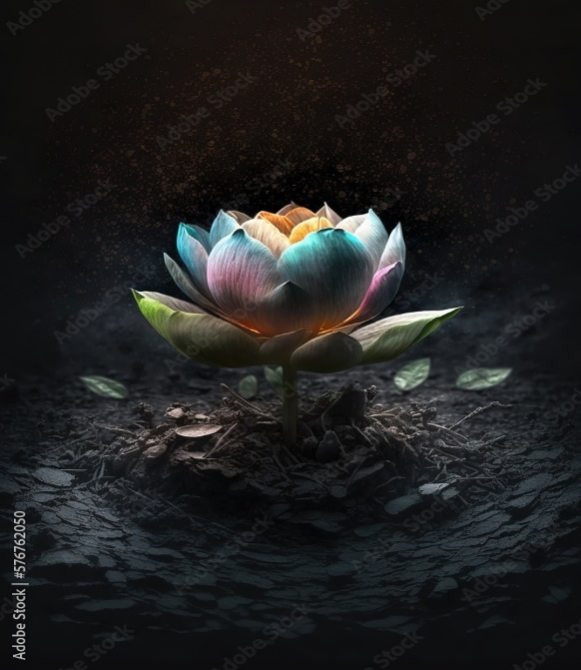

“*As a lovely white lotus*

*is not soiled by the water,*

*I am not soiled by the world:*

*therefore, O brahmin, I am a Buddha”[8]*

* The following verse from Sutta Nipatha also describes how the Buddha emerges, just as a lotus flower does, from the muddy pond of samsāra:

*“…Suppose there was a blue water lily, or a pink or white lotus. Though it sprouted*

*and grew in the water, it would rise up above the water and stand with no water clinging to it. In the same way, though I was born and grew up in the world, I live having mastered the world, unsullied by the world”* [9]

♦ **Buddha is Worthy to Receive Offerings**

*“The honourable Buddha deserves the sacrificial cake,  
he is the unsurpassed field of merit,  
the receptacle of sacrifice for all the world:  
what is given to the worthy one brings great fruit.”[10]*

**▲Tathāgata**

According to scriptures the Buddha, referred to himself to his disciples, followers and the rest of the world as ‘**Tathāgata**’, which means fully awakened one [11] : (one who has thus (*tatha*) gone (*gata*) or “one who has thus (*tatha*) come (*agata*). The following quotes from the scriptures show why the Buddha was called the Tathāgata.

♦ **Tathāgata is Fully Awakened**

The Buddha said:

*“ …bhikkhus, 1) in this world with its devas, Māra, and Brahmā… and humans… whatever is seen, heard, sensed, cognized, reached, sought after, examined by the mind—all that the Tathāgata has fully awakened to therefore he is called Tathāgata 2) whatever the Tathāgata speaks, utters, or expounds in the interval between the night when he awakens to the unsurpassed perfect enlightenment and the night when he attains*

*final nibbāna, all that is just so and not otherwise, therefore …3) as the Tathāgata*

*speaks, so he does; as he does, so he speaks. Since he does as he speaks and speaks*

*as he does, therefore… 4) in this world with its devas… the Tathāgata is the vanquisher, the unvanquished, the universal seer, the wielder of mastery; therefore, he is called Tathāgata”* [12]

♦ **Tathāgata is an Accomplished One**

When the Five Ascetics[13] addressed him as ‘friend’ the Blessed One said:

*“…do not address the Tathāgata by name and as a ‘friend’, the Tathāgata is an Accomplished One, a Fully Enlightened One. Listen…the Deathless has been attained…”[14]*

**♦Tathāgata Appears for the Welfare of the World**

“… *there is one person who arises in the world for the welfare of many people, for the happiness of many people, out of compassion for the world, … the manifestation of one person is rare in the world…* *is extraordinary…* *is unique, without a peer, without counterpart, incomparable, matchless, unrivaled, unequalled,* …*the foremost of bipeds…* *the manifestation of one person is the manifestation of great vision…great light…the realization of the fruit of true knowledge and liberation…realization of fruit of stream entry… arahantship…* *Who is that one person? The Tathāgata, the Arahant, the Perfectly Enlightened One”[15]*

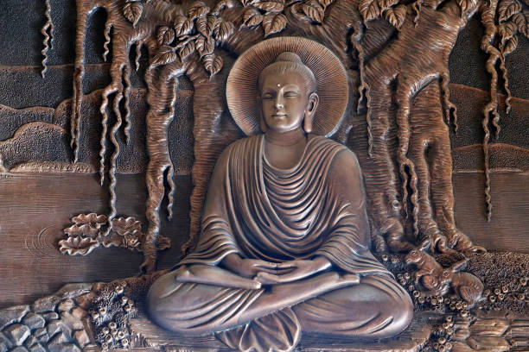

**Enlightened Buddha under the Bodhi Tree:** Picture courtesy: Getty Images

♦ **Tathāgata has Many Distinguishing Qualities**

Following suttas elaborate this point:

|  |
| --- |
| *“Having renounced sensual pleasures, faring triumphant, he who has known the end of birth and death,  who has attained nibbāna, cool as a lake: the Tathāgata is worthy of the sacrificial cake.* |
| *The same as the righteous, far from the unrighteous, the Tathāgata is one of boundless wisdom, untainted here or beyond: the Tathāgata is worthy of the sacrificial cake* [16]  * The householder Upali honors the qualities of Tathāgata  *“Of supreme serenity, with extensive wisdom,*  *a man of great wisdom, devoid of all greed;*  *He is the Tathāgata, he is the Sublime One,*  *the person unrivalled, the one without equal;*  *He is intrepid, proficient in all:*  *The Blessed One is he, and I am his disciple”*  *[17]* |

▲**Sammā Sambuddha: Fully Enlightened Buddha**

This is one of the nine noble qualities attributed to the Buddha. Samma Sambuddha are Pali words which means, ‘*he who has attained enlightenment by his own efforts*’. He does so- without a teacher, who has discovered the ancient path to liberation, he teaches Dhamma and establishes a community of followers who follows his teaching, forming and support the establishment of the dispensation (Buddha Sasana) [18].

The Buddhist world also referred to the Buddha in this way. In during their daily chanting the Buddhists, pay homage to the Blessed One like thus:

“Namotassa Bhagavato Arahato Sammā Sambuddhassa”

(Homage to the Blessed One, Accomplished and Fully Enlightened One)

In following suttas described why the Blessed One is called Fully Enlightened One:

*♦ “Bhikkhus, the Tathāgata, the Arahant, the Perfectly Enlightened One, liberated by non-clinging through revulsion towards form, feeling, perception, volitional formations… consciousness, through its fading away and cessation, is called a Perfectly Enlightened One”[19]*

♦ In Mahâpadāna Sutta (DN: 14) the Buddha said:

*“And, monks, in this present fortunate aeon I too have now arisen in the world as a fully-enlightened Buddha… I am now the Arahant and fully enlightened Buddha, and am of the Gotama clan.”*

♦ One time King Pasenadi of Kosala [20] approached the Blessed One and asked:

“*Does Master Gotama too claim, ‘I have awakened to the unsurpassed perfect enlightenment’?*

The Buddha said:

*“…I, great king, have awakened to the unsurpassed perfect enlightenment”[21]*

♦ In the following sutta the Buddha points out why he was called Samma Sambuddha:

*“Bhikkhus, there are these Four Noble Truths. What four? The noble truth of suffering … the noble truth of the way leading to the cessation of suffering. It is because he has fully awakened to these Four Noble Truths as they really are that the Tathāgata is called the Arahant, the Perfectly Enlightened One*” [22]

♦ **Noble Qualities of the Fully Enlightened Being**

*“He has severed craving and become the Enlightened One,*

*cleared of all fumes, completely untainted;*

*Most worthy of gifts, most mighty of spirits,*

*most perfect of persons, beyond estimation;*

*The greatest in grandeur, attained the peak of glory:*

*The Blessed One is he, and I am his disciple.”[23]*

▲**Jina[24]**

The Buddha has called himself ‘Jina”—Victor, because he was the conqueror who defeated Mara’s army and won the supreme victory—the Buddhahood. In following suttas described why the Buddha is called Jina.

♦ One time when the Buddha was travelling towards Benares (Varanasi), Ājīvaka Upaka [25], seeing the Buddha asked:

*“Sir, your senses are clear and your skin is pure and bright. In whose name have you gone forth? Who is your teacher, whose teaching do you follow?”*

Buddha replied:

*“I’m the victor, the knower of all. Abandoning all, I’m not soiled by anything.*

*Through my own insight, I’m freed by the ending of craving—*

*So, who should I refer to as a teacher? I have no teacher;*

*No-one like me exists in the world with its gods, I have no equal”*  [26]

**Note:** *The title Jina is also known as Anantajina—Universal Victor: see: MN:26. * Dhammpada (Dhp:353) also mentioned the above verse.

♦ On one occasion Cunda the smith’s son[27] asked the Buddha:

“*Whom do the buddhas call a conqueror of the path?”*

The Buddha replied thus:

*“ One who has crossed over perplexity, free of inner darts,  
delighted with nibbāna, without any greed;  
the guide of this world together with its devas:  
the buddhas call the impartial one a conqueror of the path” [28]*

♦ **Devas Addressing the Buddha as Victor**

Āṭānāṭiya Sutta (DN:32) we can see Devas paying homage to the Buddha as Victor (Conqueror)

*“Often asked, do we revere*

*Gotama the Conqueror? —*

*We reply: ‘We do revere*

*Gotama, great Conqueror,*

*In wisdom trained, in conduct too,*

*Buddha Gotama, we hail!’”*

♦ **Disciples Addressing the Buddha as Victor**

In Therȋgāthā there is a verse of an elder nun who says as a nun she has spent twenty-five years without getting any peace, but remembering the Buddha—the Victor’s instruction, finally she was released:

*“In the twenty-five years since I went forth,*

*I don’t know that I had ever found serenity in my mind.*

*I had failed to find peace of heart,*

*or any control over my mind.*

*When I remembered the victor’s instructions,*

*I was struck with a sense of urgency”[29]*

**▲ Other Titles** **Attributed to the Buddha**

The scriptures mentioned following three titles: ‘**brahmin’, ‘one bearing his last body’ & ‘ an unsurpassed physician and surgeon’**. The Buddha said this to the Sangha:

*“ Bhikkhus, I am a* ***brahmin***  *ever accessible to entreaties, open-handed,*

***one bearing his last body****,* ***an******unsurpassed physician and surgeon,***

*You are my own legitimate sons, born from my mouth,*

*born of Dhamma, fashioned by Dhamma, heirs of Dhamma,*

*not heirs of material things”* [30]

**♦Brahmin**

In the scriptures the Buddha often used the word ‘**brahmin’** to referred to himself and his noble disciples who were arahants [31].

*\* “When things become clear to the keen, meditating brahmin, he remains, scattering Māra’s army, as the sun lights up the sky”* **[32]**

*\* “The brahmin who has shut out bad qualities, who is humble, free from flaws, and self-controlled, who has reached final knowledge and has fulfilled the spiritual life”[33]*

* At one time a monk asked the Buddha of things make one a brahmin.

The Buddha said:

*“Those who, having removed bad things, live always mindful,  
The Buddhas who have destroyed the fetters,  
truly they are brāhmaṇas in the world."[34]*

*\** When a devata realizing that the Buddha has crossed over the samsara he addressed the Buddha as ‘brahmin’:

*“After a long time at last I see*

*A brahmin who is fully quenched,*

*Who by not halting, not straining,*

*Has crossed over attachment to the world”[35]*

* On one occasion, the Buddha explained who a ‘brahmin’ is:

“For the brahmin there is no task to be done...

For the brahmin has done what should be done.

While he has not gained a footing in the river,

A man will strain with all his limbs;

But a footing gained, standing on the ground,

He need not strain for he has gone beyond.

This is a simile for the brahmin, O Dāmali,

For the taintless one, the discreet meditator.

Having reached the end of birth and death,

He need not strain for he has gone beyond.”[36]

**♦ Antimadehadhari**

Buddha and arahants are noble beings that carry the last body and called Bearer of the Final Body—because they have destroyed all taints, therefore, no rebirth for them [37]. Following extracts from scriptures shows that the Buddha and Arahant bear the final body.

*\* “…a bhikkhu is an arahant, consummate, with taints destroyed, one who bears his final body…”*  [38]

*\* “Having known the exquisiteness of form, the origination of feelings, how perception arises, and where it disappears; having known volitional activities as alien, as suffering, and not as self, truly that bhikkhu who sees rightly, peaceful, delights in the peaceful state. He bears his final body, having conquered Māra and his mount”.[39]*

* In Samyutta Nikaya (SN:2) related an incident of the Buddha meeting Brahma Deva Ghaṭīkāra, who was a friend of the Buddha in one of his previous lives [40] . At the end of the sutta is the following verse showing that both the Buddha and Brahma Deva Ghaṭīkāra bearing their final bodies:

*“Such was the meeting that took place*

*Between those friends from the past,*

*both now inwardly developed,*

*Bearers of their final bodies” [41].*

* In the following sutta the Buddha affirm that he bears his final body

*“He who is concentrated, who has crossed the flood,  
and has known the Dhamma with the supreme view,  
whose influxes are destroyed, who bears his final body:  
the Tathāgata is worthy of the sacrificial cake”[42]*

*\** The Buddha, one who has gone beyond, carries his final body

*“ One virtuous, wise, of developed mind,*

*Concentrated, mindful, enjoying jhāna,*

*For whom all sorrows are gone, abandoned,*

*A taint-destroyer bearing his final body”[43]*

* Upali who was a former follower of Nigaṇṭha Nātaputta, after hearing the Dhamma became a follower of the Buddha. In his garland of praises, he said thus:

“Free from perplexity, he abides contented,

spurning worldly gains, a vessel of gladness;

A human being who has done the recluse’s duty,

a man who bears his final body;

He is utterly peerless and utterly spotless:

The Blessed One is he, and I am his disciple” [44]

**♦ An** **Unsurpassed Physician and Surgeon-** *Anuttaro bhisakko sallakatto:*

This is one of the honorary titles attributed to the Buddha: he who cures the beings who are suffering in samsara, with his noble medicine: the four noble truth, indeed, he is the ‘Supreme Physician’!

In the following sutta we can see how the Buddha identified himself as supreme physician:

*\* “I am the one whose presence in the world*

*Is very rarely come upon,*

*I am the Fully Enlightened One,*

*I, O brahmin, am the supreme physician” [45]*

* The following quote from the scriptures shows how the Buddha, like a Physician, gives a noble purgative called ‘the eightfold path’ to beings who were subject to illness of samsara to be free of suffering:

*“…bhikkhus, is that noble purgative that always succeeds and never fails, and in dependence on which beings subject to birth are freed from birth; beings subject to old age are freed from old age; beings subject to death are freed from death; beings subject to sorrow, lamentation, pain, dejection, and anguish are freed from sorrow, lamentation, pain, dejection, and anguish”* [46]

* The following two extracts from the scriptures demonstrate to us how the Buddha as a spiritual physician helps beings to cure themselves from the malady of worldly life:

Telakāni Bhikkhu says that he was relieved from the poison of Samsara through the guidance of the Blessed One [47]

*Dragging it along,*

*I’m not free from grief and lamentation.*

*Who will free me from bonds in the world,*

*so that I may know about awakening?...*

*…he taught the supreme path*

*for the canceling of these.*

*For a long time, it had lain within me;*

*for a long time, it was fixed in me:*

*the Buddha cast off the knot,*

*curing the damage of poison.*

Ubbirī, a queen of Pasenadi Kosala who was grieving for the death of her only daughter, was cured by listening to Buddha’s advice. [48].

*“Oh! For you have plucked the arrow from me,*

*so hard to see, stuck in the heart.*

*You’ve swept away the grief for my daughter*

*in which I once was mired.*

*Today I’ve plucked the arrow,*

*I’m hungerless, quenched.*

*I go for refuge to that sage,*

*the Buddha,to his teaching, and to the Sangha.”*

* This is what Brahmin Piṅgiyānī, a true follower of the Buddha said: [49]

“…Just as a capable physician might instantly cure one who is afflicted, sick, and gravely ill; so too, sir, whatever one hears of Master Gotama’s Dhamma—discourses, mixed prose and verse, expositions, or amazing accounts—one’s sorrow, lamentation, pain, dejection, and anguish will vanish…”[50]

♦ **The Buddha Helped Physically Unwell People**

The Buddha not only helped beings who were mentally sick, but also addressed the bodily comfort of beings who were physically unwell. In Vinaya Pitaka: Bhesajjakkhandhaka, there is much evidence conforming to this statement [51].

* The following incident described in the Vinaya Pitaka gives and account of when, the

Buddha attended on a very sick monk who had been abandoned by the other monks from the community he lived in. This shows how the Buddha taught others by setting an example through his selfless service and acts of compassion.

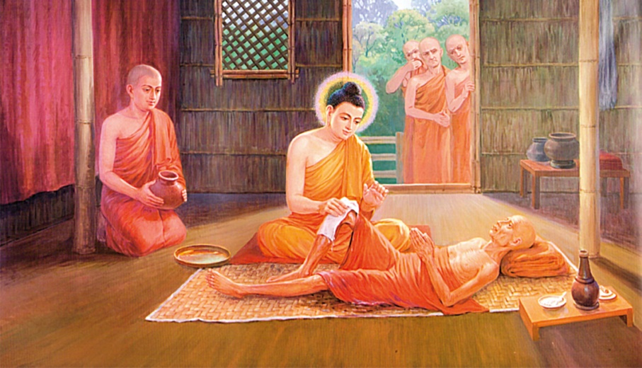

**The Blessed One attending to a sick monk**: Illustration from “The Life of the Buddha in Pictures.” Courtesy: Dhammatalks.net

* On one occasion there was a monk who had dysentery and was lying in his own feces and urine. Just then, as the Buddha was walking about the dwellings with Venerable Ānanda as his attendant, he came to the dwelling of this monk [52], when he saw his condition, the Buddha went up to him and asked:

“*What’s your illness, monk?”* *“I have dysentery, Sir.”*

*“But don’t you have a nurse?” “No.” “Why don’t the monks nurse you?”*

*“Because I don’t do anything for them.”*

Then the Buddha said to Ānanda, “*Go and get some water, Ānanda. Let’s give him a wash*.”

After the Buddha washed the sick monk and changed his robes, the monk Tissa was lying in his bed feeling happy. Standing near him the Blessed One knowing that monk Tissa was about to die and that he has the ability to break through, said to him:

‘*Monk, consciousness will depart from you, your body will*

*become useless and, like a log, will lie on the ground.”*

*( ciraṃ vatayaṃ kāyo paṭhaviṃ adhisessati*   
*chuddho apetaviññāṇo niratthaṃ'va kaliṅgaraṃ*) [53]

At the end of the discourse the monk Tissa attained arahantship and soon passed away [54].

Taking this incident to teach the monks, the Buddha said thus:

*“Monks, you have no mother or father to nurse you. If you don’t nurse one another, who will?  Whoever would nurse me, should nurse one who is sick”[55]*

“The greatest of all gains is health, Nibbāna is the greatest bliss, The eightfold path is the best of paths for it leads safely to the Deathless.”

Quote from MN:75(Māgandiya sutta)

♦ The Buddha not only attended to sick monks, but gave the following guidelines for appointing caregivers, saying that caregivers should have following qualities:

1) being capable of preparing medicine 2) knowing what’s beneficial and what’s harmful and being capable of removing what’s harmful and bringing what’s beneficial 3) being able to nurse the sick with a mind of goodwill, not for the sake of worldly gain 4) not being disgusted at having to clean up faeces, urine, spit, or vomit 5) capable of instructing, inspiring, and gladdening the sick person with a Dhamma talk from time to time” [56]

**♦ Cakkhumā- One with of Vision**

This is another title ascribed to the Blessed One. *‘Cakkhumā* (Pali) men as having eyes or sight—Cleared Eyed One, one who see the spiritual path and insight to attend liberation, according to scriptures one who has seen and penetrated the noble virtue…noble samādhi…noble wisdom and noble liberation is called ‘*Cakkhumā-* One with vision. In the following sutta the Buddha said thus:

*\* “Virtuous behaviour, samādhi wisdom, and unsurpassed liberation: these things the illustrious Gotama understood by himself. Having directly known these things; the Buddha taught the Dhamma to the bhikkhus. The Teacher, the end-maker of suffering, the One with Vision, has attained nibbāna’.*

(*Iti buddho abhiññāya, dhammamakkhāsi bhikkhunaṃ; Dukkhassantakaro satthā,* ***cakkhumā*** *parinibbuto’’ti. paṭhamaṃ)[57]*

* In Dhammapada describes the Buddha as *Cakkhumā* thus:

Of paths, the eightfold is the best of truths,

the four statements; dispassion is the best of things,

and the Clear-eyed One is the best of humans.

*maggānaṭṭhaṅgiko seṭṭho saccānaṃ caturo padā*

*virāgo seṭṭho dhammānaṃ dvipadānaṃ ca cakkhumā[58]*

* In Sakkapañha sutta (DN:21), a young Deva Gopka addressed the Buddha as One-Who-Sees:

“Each for himself must understand

That Dhamma taught by Him-Who-Sees,

And well-proclaimed. I, serving you,

Heard the Noble Ones’ good words,

And so, I’m born, a Sakka-son”

***▲* Vesarājja-Self-Confident One**

Vesarājja (Pali) means one who has supreme self-confidence, this epithet used to describe the Buddha because he possessed four kinds of self-confidence. Following quote from the scriptures points this out:

**♦ The Buddha has Four Kind of Self Confidence**

*“Bhikkhus, there are these four kinds of self-confidence that the Tathāgata has, possessing which he claims the place of the chief bull, roars his lion’s roar in the assemblies, and sets in motion the brahma wheel*  [59] *. What four?*

*(1) “I do not see any ground on the basis of which an ascetic or brahmin or deva or Māra or Brahmā or anyone in the world might reasonably reprove me, saying: ‘Though you claim to be perfectly enlightened, you are not fully enlightened about these things.’ Since I do not see any such ground, I dwell securely, fearless, and self-confident.*

*(2) “I do not see any ground on the basis of which an ascetic or ...anyone in the*

*world might reasonably reprove me, saying: ‘Though you claim to be one whose taints are destroyed, you have not fully destroyed these taints.’ Since I do not see any such ground, I dwell securely, fearless, and self-confident.*

*(3) “I do not see any ground on the basis of which an ascetic or … anyone in the*

*world might reasonably reprove me, saying: ‘These things that you have said to be obstructive are not able to obstruct one who engages in them.’ Since I do not see any such ground, I dwell secure, fearless, and self-confident.*

*(4) “I do not see any ground on the basis of which an ascetic or … anyone in the*

*world might reasonably reprove me, saying: ‘The Dhamma does not lead one who practices it to the complete destruction of suffering, the goal for the sake of which you teach it. Since I do not see any such ground, I dwell secure, fearless, and self-confident”[60]*

**♦The Buddha does not need to hide anything**

The following quote shows that everything about the Buddha is open, hence he is self-confident:

*“ Bhikkhus, there are these four things that the Tathāgata does not need to hide and three things about which he is irreproachable….*

*(1) “Bhikkhus, the Tathāgata is one whose bodily behaviour is purifi ed*

*(2) “The Tathāgata is one whose verbal behaviour is purified.*

*(3) “The Tathāgata is one whose mental behaviour is purified.*

*(4) “The Tathāgata is one whose livelihood is purified…”[61]*

**Note:** * The four things about which he is irreproachable, are the same as the four things mentioned in the above sutta. * The Mahāsihanāda sutta (MN:12) gives a detailed description of the self-confidence of the Buddha.

**▲ Ãdicca Bandhu -** **Kinsman of the Sun**

Ãdicca bandhu is another commonly usedepithet for the Buddha. (Pali: Ãdicca= Sun, bandhu=relative). Legends says that the Buddha’s clan the Sakyan clan, was referred to as Ãdicca bandhu; hence the Buddha was addressed as Ãdiccabandhu.[62]

♦ In the following sutta the Buddha referred to himself as ‘Kinsman of the Sun:

*“Restraint and abandonment, development and protection: these four strivings were taught by the Kinsman of the Sun. By these means an ardent bhikkhu here can attain the destruction of suffering”* [63]

♦ In Suttanipatha we can see the following passage: a seeker of Dhamma addressing the Buddha as Kinsman of the Sun: [64]

*“Great seer, I ask you, the kinsman of the Sun, about seclusion and the state of peace”*

♦ The following verses from the Theragatha show that the disciples of the Blessed One have addressed him in this title:

“Having heard the fine words of the Buddha,

the Kinsman of the Sun,

I penetrated the subtle truth,

like a hair-tip with an arrow” [65]

♦ “All are sons of the Blessed One—there is no rubbish here.

I bow to the Kinsman of the Sun, destroyer of the dart of craving.” [66]

♦ In Āṭānāṭiya Sutta (DN:32): Devas pay homage to the Buddha thus:

“They, having seen the Awakened One,  
the Buddha, Kinsman of the Sun,  
"From afar, do reverence him,  
who is great and fully mature”.

*▲* **More Epithets for the Buddha**

In the scriptures and also in tradition we find numerous titles given to the Buddha by devas, his direct disciples, lay followers, as well as others who have recognized his great wisdom, universal compassion, boundless teaching skills and his supreme qualities.

**♦ Mārisa [67]**

According to scriptures the devas often addressed the Buddha as mārisa—venerable sir or Lord [68].

In the following quotes from the scriptures, we can see how devas addressed the Blessed One:

* “*kathaṃ nu tvaṃ,* ***mārisa****, oghamatarī’ti*?” *[69]*

(How, dear venerable, did you cross the flood)

* “*jānasi tho thvam* ***mārisa****, sattānaṃ nimokkhaṃ pamokkhaṃ vivekaṃ?”*

(Do you know, venerable sir, emancipation, release, seclusion for beings?” [70]

**♦ The Victor in Battle -Vijitasaṅgāmaṃ**

The Blessed One is referred as ‘the Victor in Battle’ because he has triumphed over Māra’s tenfold army. [71]

* Venerable Vaṅgīsa addressed the Buddha as ‘the victor in battle’ [72].

“So, they attend on the victor in battle,

The unsurpassed caravan leader—

The disciples bearing the triple knowledge,

Who have left Death far behind”

* Below we can see Sakka the lord of the Devas and Brahmā Sahampati also referring to

the Buddha as ‘victor in battle’.

“*Rise up, O hero, victor in battle!” [73]*

*“Rise up, O hero, victor in battle!*

*O caravan leader, debt-free one, wander in the world.*

*Teach the Dhamma, O Blessed One:*

*There will be those who will understand” [74]*

* The following extract also points out that because the Buddha defeated Māra he became a Victor in Batte. On one occasion Māra approached the Blessed One who was teaching in a large assembly and said:

*“Why now do you roar like a lion,*

*Confident in the assembly?*

*For there is one who’s a match for you,*

*So why think of yourself the victor?”*

The Blessed One said:

“The great heroes roar their lion’s roar

Confident in the assemblies—

The Tathāgatas endowed with the powers

Have crossed over attachment to the world”[75]

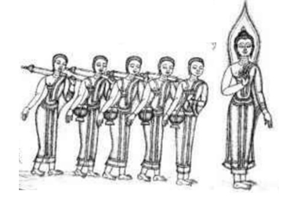

**The Buddha as a leader of a caravan showing the way to liberation**.

From DN: 1 Brahmajāla Sutta, p.64. Picture courtesy: Pang Chinasai, London, 1986.

**♦ The Caravan Leader- *satthāvāha***

The Blessed One is called ‘Caravan leader’ because he leads beings across the desert of samsāra on the chariot of the Noble Eightfold Path. [76]

In this sutta we can see the following quote by Brahmā Sahampati addressing the Buddha as the caravan leader.

“Rise up, O hero, victor in battle!

O caravan leader, debt-free one,

wander in the world. Teach the Dhamma,

O Blessed One:

There will be those who will understand.”[77]

**♦ Aṅgīrasa- The Resplendent One**

Aṅgīrasa (Pali) means resplendent or glorious. Aṅgīrasa is an epithet of the Buddha, he is the pure one, without any defilements so he shines; he is flawless hence he is radiant! [78]

* In Āṭānāṭiyasutta (DN:32), the King Vessavana Deva and other Devas pays homage to the Buddha calling him Aṅgīrasa:[79]

*“Glory to Angirasa, to the Sakyas’ radiant son,*

*Teacher of the Dhamma he that overcomes all suffering”*

*And when the Buddha greets their gaze,*

*Buddha, kinsman of the Sun,*

*From afar they offer homage*

*To the Lord of wisdom true:*

*“Hail, o man of noble race!*

*Hail to you, the first of men!*

*In kindness you have looked on us,*

*Who, though not human, honour you!*

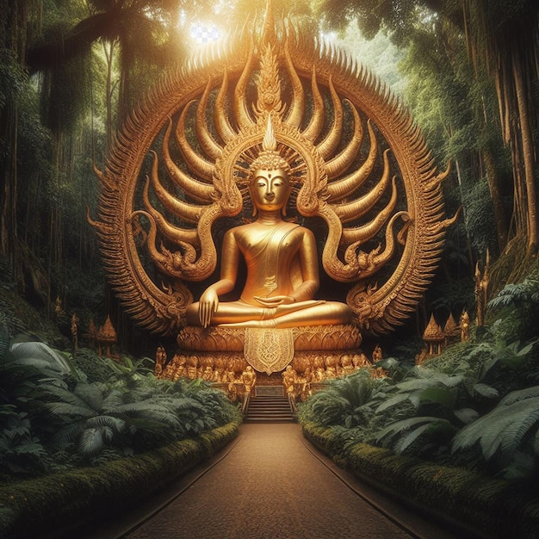

**Angirasa Buddha:** Picture courtesy: https://www.freepik.com/

* Venerable Vaṅgīsa, disciple of the Blessed One said thus:

*“As the moon shines in a cloudless sky,*

*As the sun shines devoid of stain,*

*So you, Aṅgīrasa, O great sage,*

*Outshine the whole world with your glory”[80]*

One time the Buddha was having a dialogue with five kings headed by King Pasenadi of Kosala, then the Candanaṅgalika, a lay follower of the Blessed One, seen how the Buddha’s glory surpassed of the five kings, uttered this verse:[81]

*“As the fragrant red lotus Kokanada*

*Blooms in the morning, its fragrance unspent,*

*Behold Aṅgīrasa, the Radiant One,*

*Like the sun beaming in the sky.”* [82]

**Note**: In DN: Ambattha sutta: The Buddha mentioned Angirasa as one of the 10 first sages of the Brahmins: the makers and expounders of the mantras, whose ancient verses are chanted, pronounced and collected by the Brahmins of today— Atthaka, Vamaka, Vamadeva, Vessamitta, Yamataggi, Angirasa, Bharadvaja, Vasettha, Kassapa, Bhagu .[83]

**Several Other Titles given to the Buddha**

▲**Great Ascetic (Māha Shramana)**

In the scriptures disciples, other ascetics as well as other persons also have called the Buddha as a ‘Great Ascetic’ (one who has renounced his princely life in order to find the truth of life and attained Buddha-hood) .

* Venerable Assaji said thus:

*“There’s a great ascetic, a Sakyan who has gone forth from the Sakyan clan. I’ve gone forth in his name, he’s my teacher, and I follow his teaching.”* [84]

* In here we can see Uruvelā Kassapa, dreadlocked ascetic (jatila) addressing the Buddha thus:

*“It’s not inconvenient for me, Great Ascetic, but there’s a fierce and highly venomous dragon king with supernormal powers there. I don’t want it to harm you.”[85]*

*  Brahmin householders from Magadha who saw the Buddha with Venerable Uruvelā Kassapa were not sure among the two who was the teacher and thought:

“*Is the Great Ascetic practicing the spiritual life under Uruvelā Kassapa, or is Uruvelā Kassapa practicing the spiritual life under the Great Ascetic?”[86]*

♦ **Several Tittles Bequeathed to the Budha by Devas**

On one occasion the Buddha’s foot had been cut by a stone splinter. Severe pains

assailed the Blessed One—bodily feelings that were painful, racking, sharp, piercing, harrowing, disagreeable. But the Blessed One endured them, mindful and clearly comprehending, without becoming distressed [87] . Then a group of devas visited the Buddha, having seen him enduring bodily pain with mindfulness and equanimity the group devas praised the Blessed One thus:

* **Nāga-an Elephant[88]**

“The ascetic Gotama is indeed a nāga, …and when bodily feelings have arisen that are

painful, racking, sharp, piercing, harrowing, disagreeable, through his nāga-like manner he endures them, mindful and clearly comprehending, without becoming distressed”.

**\* Sīha- Lion [89]**

“The ascetic Gotama is indeed a lion…and when bodily feelings… (as above)

**\* Nisabha- Chief Bull [90]**

“The ascetic Gotama is indeed a chief bull… and when bodily feelings… (as above)

* **Ãjānīya**- **Thoroughbred[91]**

“The ascetic Gotama is indeed a thoroughbred…and when bodily feelings…(as above).

**\* Dhorayha- Beast of burden[92]**

“The ascetic Gotama is indeed a beast of burden… and when bodily feelings…(as above).

* **Danta- Tamed [93]**

“The ascetic Gotama is indeed tamed… and when bodily feelings…(as above).

* **Suvimuttaṃ-Well liberated**

“…he is well liberated: samadhi is well developed and his mind is well liberated—not bent forward and not bent back, and not blocked and checked by forceful suppression!”[94]

**Note:** In SN:7-a deva called Pañcālacaṇḍa has praised the Buddha as ‘chief bull”

▲ In MN: Upāli Sutta, we can see, the householder Upāli, praising the Buddha with many honorary titles; a few is mentioned here: [95]

“He is the **Wise One** who has **cast off delusion**, **abandoned the heart’s wilderness**, **victor in battle**; **He knows no anguish**, is **perfectly even-minded**, **mature in virtue**, of **excellent wisdom**; **Beyond all temptations,** **he is without stain**: The Blessed One is he, and I am his disciple…”

*(Dhīrassa vigatamohassa, pabhinnakhīlassa vijitavijayassa; Anīghassa* *susamacittassa,* *vuddhasīlassa* *sādhupaññassa Vesamantarassa,* *vimalassa, bhagavato tassa sāvakohamasmi)*

**Note:** brief explanation of the titles given in the verse: **Wise One** (*Dhīrassa*) : the Buddha is endowed with great wisdom; **Cast off Delusion** (*vigatamohassa*): he has discarded the delusion of the world; **abandoned the heart’s wilderness** (*pabhinnakhīlassa)*: he has abandoned all shackles in the heart; **victor in battle** (*vijitavijayassa*): he defeated the army of Māra and won the supreme Buddha-hood; **he knows no anguish** (*Anīghassa)*: he has overcome all suffering; **perfectly even-minded** (*susamacittassa)*: he has equanimity; **mature in virtue** (*vuddhasīlassa)*: he is endowed with noble virtue; **excellent wisdom** (*sādhupaññassa)*:his wisdom is brilliant; **Beyond all temptations** (*Vesamantarassa)*: he has abandoned all defilements; **he is without stain** (*vimalassa)* he is the pure one”.

**End Notes: Section 6**

1. **Quote:** from Ratana sutta.
2. AN4:15.
3. AN4:21.
4. AN4:33
5. AN4:1 (Understood sutta).
6. **See:** MN: 92 (Sela sutta) * Similar statement is also in MN:91 (Brahmāyu sutta).
7. Dhp:14 (Translated from Pali by Bhikhu Sujato)
8. AN4:36
9. Snp: 22 (Pupphasut, translated by Bhikkhu Sujato.
10. Snp:3.4 (Sundarikabhāradvāja sutta, translated by Bhikkhu Bodhi)
11. The word ‘Tathāgata’, means the same as abhisambuddha, ‘fully awakened to’. **See**: AN: Notes: 656, p.615.
12. AN:4: 23 (World sutta). * Tathāgata is also called ‘Realized One’: Iti:112 (Loka sutta: Translated by Bhikhu Sujatho).
13. The five ascetics were the attendants of the Buddha before his enlightenment; **see**: sections 4 & 5 for more information.
14. MN: **26 (**Ariyapariyesena sutta)
15. AN1: 170-186 (Foremost).
16. Snp:3.4 ( Sundarikabhāradvāja sutta, translated by Bhikkhu Bodhi): This is an encounter of the Buddha with brahmin Sundarikabhāradvāja, who after listening to the Buddha became established in faith, became an arahant disciple.
17. MN:56 (In Upali sutta).
18. **See:** Sections 4 & 5 for details.
19. **See**: SN22:58.
20. King Pasenadi was to become one of the Buddha’s most devoted lay followers. This sutta, it seems, records his first personal encounter with the Buddha. See: SN: Notes:199, p.530.
21. SN3:1 (Young sutta)
22. SN56: 23.
23. MN:56 (Upali sutta).
24. * Jina—Oxford Reference: A title used of the Buddhas, meaning ‘victor’.
25. He is mentioned in section 4, he became a disciple of the Buddha.
26. VP:Mahākhandaka: 5 (A translation by Bhikkhu Brahmali) * This event also mentioned in MN: 26 (Ariyapariyesena sutta).
27. He was a follower of the Buddha; he offered the last meal to the Blessed One: see: DN: 16.
28. Snp:1:5 (With the Smith Chunda), translated by Bhikkhu Bodhi.
29. Thig:3.1 (Translated by Bhikkhu Sujato).
30. Iti:100 ( Brāhmaņa dhammayāga sutta translated from Pali by John D. Ireland).
31. **\***  The Buddha uttered the first udana during his first week of enlightenment: Ud:1.3. (ttranslated from Pali by Bhikkhu Sujato . * In in VP: Mahakandha: 1: also mentioned the same utterings. * The second udana: during the 2nd week of enlightenment, a brahmin visited the Buddha and asked ‘who is a brahmin’ and the Buddha replied to him in this verse: **see:** VP: Mahākhandhaka: 2. (translation by Bhikkhu Brahmali).
32. Ibid.
33. Ibid.
34. Ud:1.5 (The discourse about the elders, translated by Bhikkhu Bodhi). * In this sutta, the Buddha having seen venerable Sāriputta, venerable Mahāmoggallāna and several other bhikkhus (who are arahants) approaching him said: ‘These brāhmaṇas are coming, monks; these brāhmaṇas are coming, monks."
35. SN1:1* Spk: The Buddha is called a *brahmin* in the sense of arahant (see Dhp 388, 396-423). He is *fully quenched* (*parinibbuto* ) in that he is quenched through the quenching of defilements (*kilesanibbānena nibbutaṃ*). Craving is designated *attachment* (*visattikā*) because it clings and adheres to a variety ofsense objects, see: SN: Notes: 4.
36. SN2: 5 (Dāmali sutta). * Spk: This young deva believed that there was no end to the

    arahant’s duties and that the arahant must continue striving even after reaching arahantship. The Buddha spoke the rejoinder to correct him. The Buddha’s verse is unique (asaṅkiṇṇā) in the Tipiṭaka, for nowhere else does the Buddha criticize the arousing of energy, but here he speaks thus to show that there is a conclusion to the arahant’s duty, see: SN:Note:147.
37. In MN: 56 (Upali sutta), the householder Upali honouring the Buddha with many titles, mentioned that the Buddha is the bearer of the last body. * In AN4: 35 ( Vassakāra sutta) there is a verse saying that the Buddha is carrying his final body.
38. SN1: 25 (The Arahant sutta). * In MN:116 (Isigili sutta) mentioned that paccekabuddha Buddhas also bearer of their final body: ‘…and twelve between—Ānandas, Nandas, and Upanandas— And Bhāradvāja bearing his last body’.
39. AN:4:16 (6) sutta
40. For details: see: MN: 81 (Ghaṭīkāra sutta)
41. SN2:50 (Ghaṭīkāra sutta) * The statement that both were inwardly developed (*bhāvitattānaṃ*) and were bearing their final bodies (*sarīrantimadhārinaṃ*) implies that after his rebirth in the Pure Abodes, Ghaṭı̄kāra too had become an arahant: see: SN: Note:115.
42. Snp: 3.4 (Sundarikabhāradvāja sutta, translated by Bhikkhu Bodhi)
43. SN2:14 (Nandana sutta)
44. MN:56 (Upali sutta)
45. MN:92 (Sela sutta)
46. AN10: 108 (Physicians sutta). * AN10:109 shows how the Buddha administer noble emetic for persons to vomit the wrong view and established in right view in order to be free from all sufferings.
47. Thag:16.3 (Telakāni Thera: Verses of the Senior Monks: Translated by Bhikkhu Sujato).
48. Thig:3.5 (Ubbiri: Verses of the Senior Nuns: Translated by Bhikkhu Sujato).
49. Piṅgiyāni brahmin who was a noble disciple established in the fruit of non-returning. His daily routine was to visit the Buddha and offer him incense and garlands. After listening to him the brahmin Kāraṇapālī became a lay follower of the Buddha. **See**: AN: Notes: 1195, p. 640.
50. AN5:194.
51. “One time the monks were afflicted with autumn illness, and they could not keep down either congee or other food. As a result, they became thin, haggard, and pale, with veins protruding all over their body. The Buddha noticed this …and allowed the sick monks to take five tonics (ghee, butter, oil, honey, and syrup) both before and after midday …he also allowed medicinal roots:**(**turmeric, ginger etc. ) and plants such as nim, and other bitter leaves as medicine”. For details: **see:** VP:Bhesajjakkhandhaka: a translation of the Pali Vinaya piţaka into English by Bhikkhu Brahmali.
52. Tradition says the name of the sick monk was  [Pūtigatta Tissa](https://www.wisdomlib.org/definition/putigatta-tissa#theravada)-Monk with a Stinking Body
53. Dhp:41. * The story is give in VP: Cīvarakkhandhaka 23: The account of the one who was sick: translated by by Bhikkhu Brahmali.
54. **See**:  [Dhammapada (Illustrated)](https://www.wisdomlib.org/buddhism/book/dhammapada-illustrated) by Ven. Weagoda Sarada Maha Thero.
55. VP3: Cīvarakkhandhaka: 23 The account of the one who was sick, translated by Bhikkhu Brahmali.
56. Ibid.
57. AN4: 1 (Bhandagama sutta)
58. Dhp:273 (Translated by Bhikkhu Sujato).
59. **Brahma wheel**: referred to the wheel of the Dhamma, see: AN: Notes: 633, p.614.
60. AN4: 8 (Self-confidence sutta)
61. AN7:58 (No need to hide sutta).
62. According to Ambatta sutta (DN:3) Skyana regards King Okkāka as their ancestor. * According to the Dīpavaṃśa and the Mahāvaṃśa (ancient texts of Sri Lanka) Okkāka is the name of an ancient king from the Solar dynasty (*sūryavaṃśa*) and a descendant of Mahāsaṃmata..
63. AN4:14. * The four strivings are: by restraint, by abandonment, by development, and by protection
64. Snp:4.14 (Tuvaţaka sutta, translated by Bhikkhu Sujato).
65. Thag:16.3 ( Abhaya Thera: Verses of the Senior Monks: Translated by Bhikkhu Sujato)
66. Thag:21.1 ( Vaṅgīsa Thera: Verses of the Senior Monks: Translated by Bhikkhu Sujato)
67. *Mārisa*, as respectful term of address, something like “Sir,” pl “Sirs”, “venerable sir” (per: suttacentral) * This is the term which the devas generally use to address the Buddha, eminent bhikkhus

    (see, e.g., **40:10**; IV 270,16), and members of their own community (**11:3**; I 218,34); kings also use it to

    address one another (**3:12**; I 80,4) , Spk explains (Buddhaghosa) one without suffering (*niddukkha*), but it is probably a Middle Indic form of Skt *madṛsa*. See: SN:Note:1
68. **SN:**In Devatasamyuuta and Devaputtasamyutta there are many more suttas showing how the devas addressed the Buddha by using the title ‘mārisa’.
69. SN1.1 (Crossing the Flood sutta).
70. SN1:2 (Emancipation sutta) * Spk: Emancipation (*nimokkha*) is the path, for beings are

    emancipated from the bondage of defilements by the path; release (*pamokkha*) is the fruit, for at the moment of the fruit beings have been released from the bondage of defilements; seclusion (*viveka*) is Nibbāna, for when they attain Nibbāna beings are separated from all suffering. Or, alternatively, all three are designations for Nibbāna: for having attained Nibbāna, beings are emancipated, released, separated from all suffering”, see: SN:Note:6.
71. He has won the battle against the sensual world and freed himself. **See**: SN: Note: 517, p.568
72. SN8:7 (Pavāraṇā sutta).
73. SN11:17.
74. SN6:1
75. SN4:12.
76. **See:** SN: Notes: 517, p. 568.
77. SN11: 17 .
78. * The Buddha is called Aṅgīrasa because rays issue from his body (aṅgato rasmiyo nikkhamanti) * On Aṅgīrasa Malalasekera remarks (DPPN 1:20): “It is, however, well known that, according to Vedic tradition, the Gautamas belong to the Aṅgı̄rasa tribe; the word, as applied to the Buddha , therefore is probably a patronymic**.” see**: SN: Notes: 228, p.533.
79. The term angīrasa ‘radiant’ applies to all the Buddha, **see**: DN: Notes: 995, p. 467
80. SN9: 11 (Gaggara sutta),
81. SN3:12.
82. The same verse was said by brahmin Piṅgiyānī who was so inspired to see the Blessed One sitting amidst the colourful Licchavis of Vesālī. See: AN:4: 195 (5) sutta, p. 302.
83. * Ancient rishis associated with the Vedic hymns, **see:** DN: Notes: 163, p. 413. * In AN: the Buddha referred Aṅgīrasa as one of the 10 ancient seers who created Vedic hymns**, see**: 192 (2) Doṇa sutta, p. 298, see also: MN: Cankī sutta.
84. Venerable Assaji was one of the five ascetics (see section 3 & 4) who became a disciple of the Buddha. When wanderer Upatiis ( Venerable Saripuuta who became a great disciple of the Buddha) asked Venerable Assaji about his teacher, he replied thus. see: VP:Mahahandhaka: 14: a translation of the Pali Vinaya piţaka into English by Bhikkhu Brahmali.
85. This was the encounter of the Buddha with Uruvelā Kassapa at his hermitage; when the Buddha asked permission to stay for one night at his hermitage, Uruvelā Kassapa said thus. See:

    VP:Mahahandhaka: 12: a translation of the Pali Vinaya piţaka into English by Bhikkhu Brahmali.
86. This event occurred, when the Buddha after his enlightenment visited King Bimbisāra at Rajagaha. See: VP:Mahahandhaka: 13 : a translation of the Pali Vinaya piţaka into English by Bhikkhu Brahmali.
87. SN1:38 *
88. He is called a *nāga* on account of his strength, see: SN:Note:87.
89. He is called a *siha* on account of his frearlessness, see: SN:Note:87.
90. He is called (*nisabha*) because he is without a rival, see: SN:Note:87.
91. He is called (*ājānīya*) because he know what is right and what is wrong, see: SN:Note:87.
92. He is called (*dhorayha*) because of bearing the burden, see: SN:Note:87.
93. He is called (*danta*) because he is free from deviant conduct, see: SN:Note:87.
94. See: SN: Note: 88.
95. Upāli was a prominent wise and wealthy householder of Nāḷandā , who was a follower of Nigaṇṭha Nātaputta, at a later date he met the Blessed One, listened to the Dhamma and became a stream-winner. When questioned by Nigaṇṭha Nātaputta: ‘whose disciple should we consider you to be…’ Upāli uttered the verses praising the Buddha. For details: see; MN: Upāli sutta.